**Software Defined Network in 5G**

A dissertation submitted to

**UKA TARDASIA UNIVERSITY**

in Partial Fulfillment of the Requirements for the Degree of

**Master of Science**

in

**Information Technology**

By

**PATEL BHUMIK DIPAKBHAI**

**(201806100110100)**

**KADIWALA DARSHIL KIRANKUMAR**

**(201806100110084)**

Guided by

**Mr. Hardik Vyas**

**Assistant Professor**



**Babu Madhav Institute of Information Technology**

**Uka Tarsadia University**

**Bardoli - 394350**

**May 2022**

**CANDIDATE’S DECLARATION**

**I/We declare that the dissertation for M.Sc.IT. entitled Software Defined Network in 5G is my/our own work conducted under the guidance of Mr. Hardik Vyas.**

**I/We further declare that to the best of my/our knowledge, the dissertation does not infringe upon anyone’s copyright nor violate any proprietary rights and that any ideas, techniques, quotations, or any other material from the work of other people included in my/our dissertation, published or otherwise, are fully acknowledged in accordance with the standard referencing practices.**

**Place: Uka Tarsadia University**

**Date: May 12, 2022**

**201806100110100,** **Patel Bhumik Dipakbhai**

**201806100110084, Kadiwala Darshil Kirankumar**

**CERTIFICATE**

This is to certify that research work embodied in this dissertation entitled **Software Defined Network in 5G** was carried out by **Patel Bhumik Dipakbhai** (Enrolment no.: 201806100110100) and **Kadiwala Darshil Kirankumar** (Enrolment no.: 201806100110084) at **Babu Madhav Institute of Information Technology** for the partial fulfillment of **Master of Science in Information Technology** degree to be awarded by **UKA TARSADIA UNIVERSITY**. This research work has been carried out under my supervision and is to my satisfaction.

**Date: May 12, 2022**

**Place: Uka Tarsadia University**

|  |  |
| --- | --- |
| **Mr. Hardik Vyas**  **Guide** | **Dr. Jitendra Nasriwala**  **I/C Director** |

**External Examiner**

|  |
| --- |
|  |
|  |

**Seal of Institute**



**Babu Madhav Institute of Information Technology,**

**Uka Tarsadia University,**

**Bardoli - 394350**

**Acknowledgements**

*Our heart pulsates with the thrill for tendering gratitude to those persons who helped me in completion of the project.*

*We expend our deep sense of gratitude and indebtedness to our guide Mr. Hardik Vyas for their kind attitude, invaluable guidance, keen interest, immense help, inspiration and encouragement which helped us carrying out our present work.*

*Lastly, we thank all those are involved directly or indirectly in completion of the present project work.*

**Patel Bhumik Dipakbhai**

**Kadiwala Darshil Kirankumar**

***Abstract***

*The world is moving at a high speed in the implementation and innovations of new systems and gadgets. The evolution of wireless network from the first to 4th generation has made smart devices and technologies a significant part of our daily activities. A Software defined network (SDN) in a 5G (fifth generation) network that can be faster and reliable.5G promise faster and superior quality with better security guarantee in comparison to preceding technologies. The software defined network on the other hand is an enabling technology needed to actualize the huge promise of 5G network. With extensive network 5G, a centralized controller approach in SDN has limitations related to the performance and scalability. Control placement problem (CPP) becomes more of a challenge, especially when network nodes/links and controllers have some constraint metrics such as latency, network load and distance. This documentation proposes a multi-criteria clustering methods that places the controllers based on a predefined constraint metrics between the controllers and the switches while minimizing the overall latency. The result showed the proposed technique improved node distribution then existing solutions for a dense network anticipated with clustering network in software defined network in 5G.*

*Index Terms: - Software defined network,5G network, Controller placement problem, Control plan, Scalability.*

**ABBREVIATIONS**

|  |  |
| --- | --- |
| SDN | Software Defined Network |
| CPP | Controller Placement Problem |
| E2E | End-to-end |
| NFV | Network Function Virtualization |
| IP Address | Internet Protocol Address |
| SGW | Service Gateway |
| EKC | Extended K-Critical |
| LTE | Long Term Evaluation |
| MIMO | Multiple Input Multiple Output |
| EPC | Evolved Packet Core |
| ND | Neighbor node Discovery |

**Table of Content**

|  |  |  |  |
| --- | --- | --- | --- |
| **Chapters** | **Particulars** | | **Page no.** |
|  | | | |
|  | Introduction | | 1 |
|  | Introduction of SDN | 1 |
|  | Introduction of SDN in 5G | 3 |
|  | | | |
|  | Related Work | | 5 |
|  | | | |
|  | Proposed Work | | 7 |
|  | | | |
|  | Conclusion | | 10 |
|  | | | |
|  | Reference | | 11 |

**List of Figures**

|  |  |  |
| --- | --- | --- |
| **Figure No.** | **Figure Name** | **Page no.** |
|  | | |
|  | SDN Architecture | 2 |
|  | N/W Slicing | 4 |
|  | Network distribution with 2000 nodes and 2000 x 2000 meter area | 6 |
|  | Ideal node selection process (Comparative solution) | 9 |

1. Introduction

Traditional networking approaches have become too complicated and proprietary. They have become barrier to creating new services within single or interconnected data center [1]. The basic problem of network’s constraint is that it is set up on switches, routers, bridges and other devices that they have become intricate because they implement ever-lasting number of distributed protocols and use proprietary interfaces. In such environment, it is difficult to network operator’s or even vendor to manage and customized network configuration as per the requirements and thus susceptible to error. Networks continue to have problems with security, controllability and adaptability that have been successfully described so far [5]. However, as current and emerging internet application and services become more complex and challenging.

* 1. Introduction of SDN

Software Defined Networking facilitate network evolution. The SDN paradigm decouples the control planes and data planes, therefore all network intelligence and control logic is migrated from the network devices to a logically centralized software-based entity known as the network controller. The centralized characteristic of SDN implies that the network controller is always aware of the network state and that all traffic flows are passed to the controller at least once in the network lifetime for the definition of forwarding behavior.

Software Defined Networking facilitate network evolution. The SDN is paradigm in which control plane is separated from forwarding data plane. In SDN, the control plane is logically centralized by controller to take network management decisions without interfering network administrator and underlying network devices become simply packet forwarding data plane.

SDN embodies the concept of network programmability since all network operations must be described as software programs, integrating algorithms, data structures and programming concepts that belong to the software development environment. There are different tasks are separated by different planes [9].

There are three planes:

* Control plane
* Data plane
* Application plane

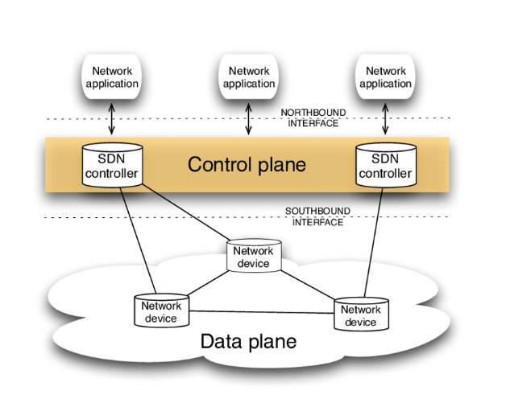

Figure 1: SDN Architecture

1. **Application plane**

SDN Application plane is a program that directly communicates their network requirements with SDN controller through North-bound Interfaces (NBI).

SDN Application consists of different Management Services, Security App, SDN logic and NBI drivers.

1. **Control plane**

Centralized Control Plane is responsible for transferring requirements of application layer to SDN data path. Control plane consists of Control-to-Data Plane Interface (CDPI) Agents, NBIAgents, SDN logic and Network OS.

1. **Data plane**

This plane comprises of data forwarding network devices, CDPI agents, traffic forwarding engines and traffic processing functions. This plane communicates with Control Plane through CDPI to follow the instructions from controller.

OpenFlow is a communication protocol which gives access to data plane over the network. OpenFlow is based on an ethernet switch which consists of flow table and action associated with each flow entry. The network administrator on one side, SDN provides interaction between controller to data plane to access network resource to deploy new functionalities and handle the network behavior from centralized controller. On other side, SDN architecture is susceptible to malicious applications and security attacks. Hence Networking security is very important for successful deployment of network technology.

SDN can be used in several domains like:

1. SDN in service function chaining (SFC)
2. VNF (Virtual n/w function)
3. SDN for IOT
4. Quality of service in SDN
5. Load balancing SDN
6. SDN in 5G mobile n/w
7. AI enabled in SND
   1. Introduction of SDN in 5G

As you can see from the preceding parts, 5G will be a massive network with several complications. Its control and management activities cannot be controlled in the same way as its other operations. 2G and 3G systems are examples of legacy systems. 5th generation (5G) technologies are now being researched to meet current and future consumer, service, and corporate demands. It ensures that the functionalities of distinct layers are well specified.

It gives the whole network an appropriate control and management structure. It may aid network management in a variety of ways for both operators and suppliers. Because 5G will be a sophisticated heterogeneous network, its administration and control will be similarly difficult. The motive for SDN in 5G and related concerns are presented here.

This new generation 5G of wireless broadband network will provide the fundamental infrastructure for billions of new devices with less predictable traffic patterns will join the network. To be succeed with this new technology, going through intelligence is really crucial, to proceed to successful deployment and realization of a powerful wireless world.

* **Network Slicing**

Fifth-generation (5G) technologies are now being researched to meet 2020 and beyond consumer, service, and corporate demands. The requirement to serve a number of vertical industries such as manufacturing, automotive, healthcare, energy, and media and entertainment is one of the primary drivers of 5G systems. A resource is a controllable unit defined by a collection of traits or capabilities that may be utilized to perform a service in its broadest definition. A network slice is made up of a group of resources that, when coupled properly, satisfy the service needs of the use case it serves. We examine two categories of resources in network slicing [2].

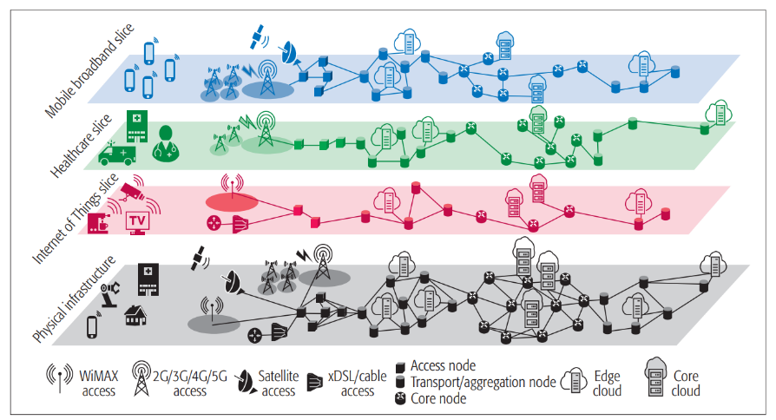

Figure 2: N/W Slicing [2]

1. **Network Functions (NFs)**

Functional blocks that provide specialized network capabilities in order to support and materialize the unique service(s) required by each use case. NFs can be physical (a mix of vendor-specific hardware and software constituting a typical purpose-built physical appliance) or virtualized (network function software is detached from the hardware it runs on) [2].

1. **Infrastructure Resources**

For hosting and connecting NFs, heterogeneous hardware and software are required. Computing gear, storage capacity, networking resources (e.g., connections and switching/routing devices that enable network connectivity) and physical assets for radio access are all included. The aforementioned resources and their properties must be abstracted and conceptually partitioned using virtualization technologies, defining virtual resources that may be used in the same way as physical resources for network slicing [2].

We describe network slices as end-to-end (E2E) logical networks that are mutually separated, have autonomous control and administration, and may be constructed on demand on a shared underlying (physical or virtual) network. These self-contained networks must be able to accept a variety of business-driven use cases from many parties on a single network architecture [2].

1. Related Work

This research work contains the concept of SDN and its architecture and how it’s working. The SDN architecture consist of three layers application layer, control layer, infrastructure layer. This article the consist of SDN OpenFlow control. 5G network connection use the concept of SDN. This article covers SDN OpenFlow management. Cellular network topology generated with two different stations linked with software with centralized network (Ex. “sta1” and “sta2” linked with ap1 with C0) [1].

The data transmission rate would increase by an average of 5 Mbps that will enable faster and convenient communications. And then connect with end-user to 5G cellular network and check the IP address and specific durations and toped up with credit amounts after the units get exhausted. The percentage of the results collected from the network survey indicated that the confidence interval for the network to be effective was 95% [1].

Network slicing for 5th generation with SDN and NFV concepts and its challenges. In Network slicing there are various slice of network. It will manage multivendor and multi access network. There are the challenges in network slicing. Performance issue in shared infrastructure, management issue, security and privacy. In this documentation, identify the main challenges and future research arising from implementing slicing in 5G systems is: Performance issues in a shared infrastructure, Management and orchestration issues, Security and privacy. A high number of research papers have been published discussing how the EPC (Evolved Packet Core) would be virtualized, and proposing new architectures that integrate SDN [2].

Their integration offers promising possibilities to adequately meet the slicing requirements. Indeed, many 5G research and demonstration projects (e.g., 5GNORMA, 5GEx, 5GinFIRE, and 5GPagoda) are addressing the realization of 5G slicing through the combination of SDN [2].

Managed HTTP traffic specification table, Simulation parameters table and calculate delay, throughput [4].

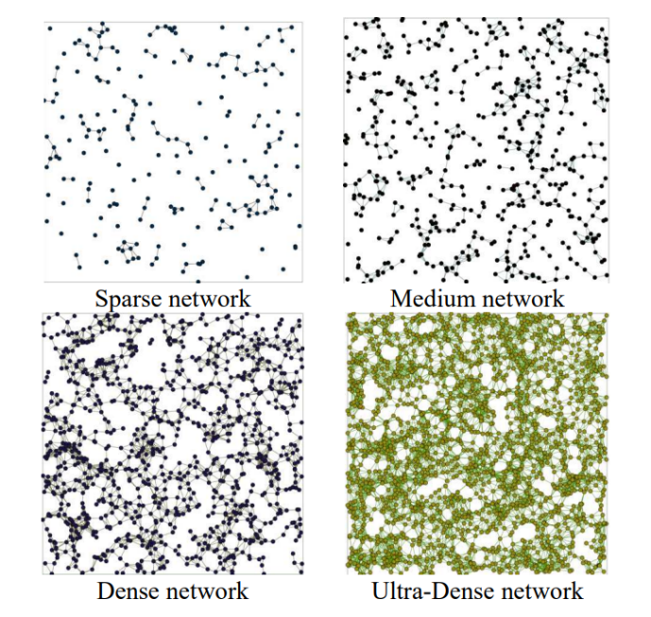

Figure 3: Network distribution with 2000 nodes and 2000 x 2000 meter area [5]

The CPP (controller placement problem) needs to be critically examined in order to guarantee efficient network performance and scalability. In large-size network with substantial path delays, the controller placement limits the controller’s response to real-time action sensed by the data plane [5].

There are several related works on the placement of controller in SDN. e.g., Extended K-Critical (EKC) algorithm [5].

Minimizing the load on the SGW-C: Minimizing the load on SGW-C, while maintaining the SGW relocation frequency under a fixed threshold by using the same notation as in the previous model [9].

Minimizing the SGW (Serving Gateway) relocation.

Pareto-optimal solution: In this approach use game theory, specifically Nash bargaining game and threat value model, to derive the Pareto optimal solution – named Fair and Optimal SGW-C placement in 5G Network (FOSNet) – that satisfies both objectives in the same time; i.e., minimizing the SGW relocation and traffic load on each SGW-C [9].

1. Proposed Work

There are some challenges in 4G and 5G LTE (Long term evaluation).

1. **Multiple services**

5G is distinct from existing radio signals in that it would be responsible for supplying services to a wide range of networks, procedures, and devices operating in different geographic locations.

To satisfy people's high expectations, standardization is the responsibility of offering dynamic, universal, user-centered, and data-rich wireless services.

1. **The cost factors**

5G technology isn’t compatible with previous generations. This leads to building the groundwork for something new, not the establishment of just a layer on top of an existing network.

So, building a network is costly and money will be also raised by carriers. Also, 5G technology requires skilled engineers to install and maintain the 5G networks, 5G equipment is expensive, which increases 5G deployment and maintenance costs.

1. **Old devices may go out of use**

Due to the usage of new technologies in 5G, older devices will be useless because their system and characteristics won’t support the latest 5G technology features.

1. **Deployment and coverage**

The coverage range is up to 2 meters (indoors) and 300 meters (outdoors) due to higher frequency losses. 3G cell towers could cover vast territory with relatively few cells because the network did not require as much bandwidth.

1. **Ultra-low latency service**

To guarantee smooth operation, mission-critical apps and self-driving cars involve ultra-low latency facilities. Any delay in mission-critical apps could lead to unexpected and catastrophic outcomes. It is necessary to achieve a latency of less than 1 millisecond to fulfill medical apps such as remote surgery.

1. **Security issues**

Security is one of the most significant variables of any wireless transmission system. A 5G Network must guarantee safety and privacy for end customers. Given the number of devices linked to the network and the variety of techniques, ensuring safety is a difficult job. The IoT can make life simple for the masses, but it brings out a lot of private data through the mode of exchange.

1. **Complexity**

Previously, we have clarified that the 5G mobile network uses MIMO technology. So, to provide consumers with highspeed data transmission, complex MIMO antenna arrays will be used. MIMO technology in both base stations and user equipment needs complicated algorithms and device capabilities.

In addition, to reduce transmission energy waste, the new generation of wireless transmission technology will employ beamforming techniques to effectively transfer information to user devices.

This method aids in lowering the operational power of the base station. Beamforming, on the other hand, is a difficult activity that demands a lot of computing power at base stations to locate each device within a cell.

As we can see from the problems of SDN in 5G network technology, the answer is:

* + - Assume that one SDN cellular 5G n/w is deployed across a vast region, such as the entire nation, and that it behaves like a head n/w (parent node), with that head node connected to another cellular n/w with the same configuration.
    - Ex. In one city deployed 5 cellular networks in that 5 n/w one head node n/m is deployed. That 5 cellular networks clustered this as one clustered(group). In that 5 n/w clustered one cellular n/w s been idle. So that 4 n/w are working actively and one is in a preserved mode.
    - Why we doing this thing because in one cellular n/w having multiple services doing the n/w peek time MIMO (multiple input multiple output) is on peek time. So that wise network traffic was occurred and traffic was increased so load will be increased respectively.

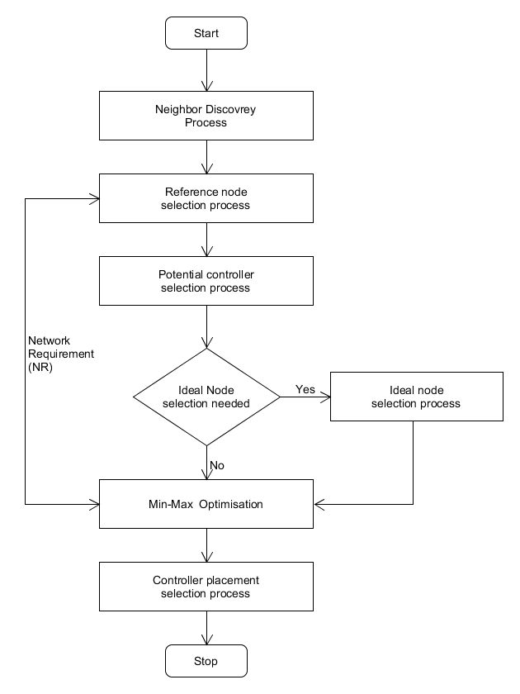

Figure 4: Ideal node selection process (Comparative solution)

The above figure is for selecting the ideal node for a cluster area network. The Neighbor node Discovery (ND) process limits the search area between nodes. The goal of the ND process to determine the actual distance between nodes. For each node, a predefined delay requirement is assigned to network links.

After the ND process, selecting a references node that is used as a reference to define the set of candidate nodes. A reference node is a node that is not in any cluster, and that has the furthest distance to the set of switches that are in a cluster.

It is discovering the controller placement from the set of candidate nodes by creating a sub-cluster from each candidate node. This consists of all the nodes that may be managed by the candidate node. After that end user connect with cellular network and after that cellular network having dense traffic situation cellular network is check the min-max optimization to another neighbor node. A neighbor node has ultra-dense traffic network it will be send the network load to ideal node. So that traffic will be distributed and availability and accessibility of bandwidth and services are fulfilled to end user.

1. Conclusion

- We have gone through the important aspects of software defined networking in 5G. The role SDN in 5G networking is inevitable. One part of the distributed SDN control issue is the difficulty of deciding the number and position of controller. To manage the broad network category, a sufficient number of controllers should be placed in a suitable location in the network so that it will easier to manage the network. The SDN based central structure is essential to take the advantages of such elegance in the network.

The Software Defined network (SDN) offers virtualization and it has enabled SDN to be the most attracting point by many researchers.

We have shown that the complex and advanced features are very difficult to be managed in the traditional way. SDN is the right choice to manage the operations in 5G networks. Programmable components and flexible architecture can provide the agility needed in 5G. However, the SDN based central structure is essential to take the advantages of such elegance in the network.

We used the clustering controller placement techniques to 5G cellular network for agility and flexibility. These two components are very important in 5G networking.

1. References

[1] Alghamdi, Khaled, and Robin Braun. "Software defined network (SDN) and OpenFlow protocol in 5G network." Communications and Network (2020).

[2] Ordonez-Lucena, Jose, et al. "Network slicing for 5G with SDN/NFV: Concepts, architectures, and challenges." IEEE Communications Magazine 55.5 (2017): 80-87.

[3] Tayyaba, Sahrish Khan, and Munam Ali Shah. "Resource allocation in SDN based 5G cellular networks." Peer-to-Peer Networking and Applications 12.2 (2019): 514-538.

[4] Tadros, Catherine Nayer, Mohamed RM Rizk, and Bassem Mahmoud Mokhtar. "Software defined network-based management for enhanced 5G network services." IEEE Access 8 (2020): 53997-54008.

[5] Syed-Yusof, Sharifah K., et al. "Software-Defined Networking (SDN) and 5G Network: The Role of Controller Placement for Scalable Control Plane." 2020 IEEE International RF and Microwave Conference (RFM). IEEE, 2020.

[6] Tayyaba, Sahrish Khan, and Munam Ali Shah. "5G cellular network integration with SDN: Challenges, issues and beyond." 2017 International conference on communication, computing and digital systems (C-CODE). IEEE, 2017.

[7] Nilofer Fatma, Jihad Qaddour. "Integration of SDN and 5G and Its Related Challenges and Security Issues." 2019 Scientific & Academic Publishing.

[8] Ksentini, Adlen, Miloud Bagaa, and Tarik Taleb. "On using SDN in 5G: The controller placement problem." 2016 IEEE Global Communications Conference (GLOBECOM). IEEE, 2016.

[9] Routray, Sudhir K., and K. P. Sharmila. "Software defined networking for 5G." 2017 4th international conference on advanced computing and communication Systems (ICACCS). IEEE, 2017.